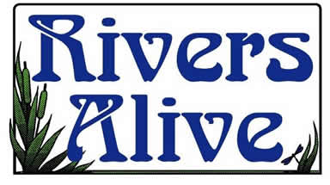
Keep Barrow Beautiful (KBB) locally present Rivers Alive events. Join community volunteers and City of Auburn staff at our annual stream cleanup event as we remove trash, litter, and debris from one of our local creeks. This is a great volunteer opportunity for scouts, civic groups, environmental clubs, and families!
Volunteer registration is now open for Georgia’s annual clean-up initiative, November 18, 2023. The clean-up will take place from 8:00 AM to 1:00 PM at Shackelford Park located at 476 Brown Bridge Road, Auburn.
All volunteers must wear closed-toe shoes and long pants, and bring gloves, water, and insect repellent. Also, volunteers must have the Rivers Alive volunteer waiver form completed and signed at the beginning of the event.
For more information or to register, contact Iris Akridge at (770) 963-4002 X 207.

